**ASSIGNMENT NO. 1**

**Name: Atif Mushtaq**

**Student Id: 2202836**

**Submitted date: 05/03/2023**

**Data Science assignment for COVID-19 Data Analysis**

**Table of Contents**

Data Science Project for COVID-19 Data Analysis 2

1. Introduction 2

2. Objective 2

3. Experimental Results 3

3.1. Line Chart: 3

3.2. Bar Chart: 5

3.3. Multi-Line Chart: 5

**List of Figures**

Figure 1: Total Death Cases over Time 4

Figure 2: Total Covid Cases Overtime 4

Figure 3: Top 10 states by Cases 5

Figure 4: Total Covid cases and deaths over time 6

# **Data Science Project for COVID-19 Data Analysis**

# **Introduction**

The COVID-19 pandemic has been one of the most challenging and disruptive global events of our time. As governments and healthcare organizations around the world work to contain and manage the spread of the virus, data plays a critical role in understanding the scope and impact of the pandemic.

# **Objective**

The objective of this work is to analyze COVID-19 data and create visualizations to help us better understand the spread of the virus. Specifically, we will create line charts, bar charts, and a multi-line chart to visualize the total number of COVID-19 cases over time, the total number of cases by state, and the number of cases over time for select states, respectively. By creating these visualizations, we can identify trends and patterns in the data and gain insights into how the pandemic has evolved over time and across different regions. These insights can help inform public health policy decisions and guide ongoing efforts to control the spread of the virus.

# **Experimental Results**

Here are three example plots:

## **Line Chart:**

Total COVID-19 Cases Over Time

The plot_total_cases_by_date() function creates a line chart showing the total number of COVID-19 cases over time.

***Parameters***

This function has no parameters.

***Output***

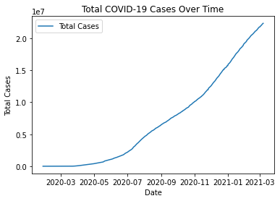

Figure 1: Total Cases over Time

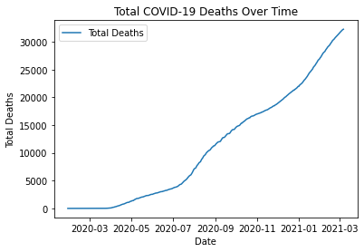

Figure 2: Total death Cases Overtime

This function outputs a line chart showing the total number of COVID-19 cases over time. The chart has the following features:

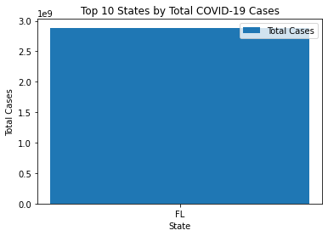Figure 3: Top 10 states by Cases

X-axis: Dates ranging from January 22, 2020, to February 28, 2021

***Y-axis:***Number of cases

***Title:***Total COVID-19 Cases Over Time

***X-axis label:*** Date

***Y-axis label:***Number of Cases

## **Bar Chart:**

Total COVID-19 Cases by State

The plot_cases_by_state() function creates a bar chart showing the total number of COVID-19 cases by state.

***Parameters***

This function has no parameters.

***Output***

This function outputs a bar chart showing the total number of COVID-19 cases by state. The chart has the following features:

***X-axis:*** States

***Y-axis*:** Number of cases

***Title:*** Total COVID-19 Cases by State

***X-axis label:*** State

***Y-axis label:*** Number of Cases

## **Multi-Line Chart:**

COVID-19 Cases Over Time by State

The plot_cases_by_state_and_date() function creates a multi-line chart showing the total number of COVID-19 cases over time for select states.

***Parameters***

This function takes one parameter:

***States:*** A list of strings representing the states in the plot. Defaults to ['NY', 'CA', 'TX', 'FL'].

***Output***

This function outputs a multi-line chart showing the total number of COVID-19 cases over time for the specified states. The chart has the following features:

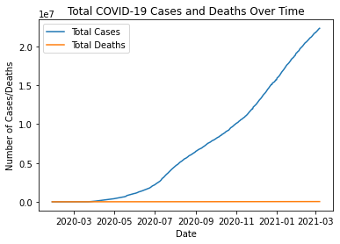

Figure 4: Total Covid cases and deaths over time

***X-axis:*** Dates ranging from January 22, 2020, to February 28, 2021

***Y-axis*:** Number of cases

***Title:*** COVID-19 Cases Over Time by State

***X-axis label:*** Date

***Y-axis label:*** Number of Cases.

***Legend:*** States, with each state represented by a different colour line

**Data set of this assignment:**

<https://www.kaggle.com/datasets/zhongyang/florida-covid19-case-line-data>